 | - connecting older people and carers to community services  - accessing befriending support opportunities  - accessing volunteering and wellbeing activities |  |  |  |  |  |  |  |  |  |  |  |  |  |  |  | Link-up  Call 0141 280 0129
 | - self directed support  - carers’ assessment  - learning opportunities  - complementary therapies  - emergency planning |  | - advocacy  - emotional support  - respite  - money matters  - support groups |  |  |  |  |  |  |  |  | Carers Centre  Call 0141 941 1550  www.carerswd.org
 | - coughs or colds  - sore throat  - indigestion/sore stomach  - diarrhoea or constipation  - pain relief |  | - emergency contraception  - stop smoking  - aches and pains  - thrush |  |  |  |  |  |  |  |  |  |  |  |  | Pharmacist
 | - injury to your mouth  - advice on oral hygiene  - painful or bleeding gums |  |  | - swelling to your mouth or face  - tooth, mouth, jaw or gum pain |  |  |  |  |  |  |  |  |  |  |  | Dentist  Contact your own registered dentist or contact 111 if unregistered or out of hours
 | - blurred vision  - irritated eyes: sore, sticky or red eye  - sudden change in vision |  |  |  |  |  | Optometrist  (Ophthalmic Optician)
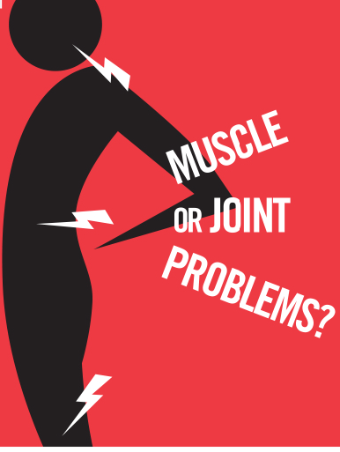 | - get advice and information to help your muscle, joint or back problems from www.nhsinform.scot/injuries |  |  |  |  |  |  | Physiotherapy  NHS MSK help APP free from iTunes, or google play store  NHS inform help line 0800 22 44 88
 | - foot pain causing a reduction in daily activities  - skin conditions: painful corns, callus etc  - nail conditions such as ingrown toenails  - non healing cuts/foot wounds, inflammation, swelling and pus |  |  |  |  |  |  |  |  |  |  |  | Podiatry  Direct access 0141 347 8909  Monday-Friday 8am-8pm Saturday 9am-1pm  HP.Appointments@ggc.scot.nhs.uk
 | - sexual health information  - emergency contraception  - termination of pregnancy services |  |  | - rape or sexual assault  - exposure to HIV  - gender identity |  |  |  |  |  |  |  |  |  | Sandyford  Call 0141 211 8130 (Sexual Health)
111 | When your GP, Dentist and local pharmacy  are closed, and you are too ill to wait  for them to re-open, call 111 free |  |  |  |  |  |  |  |  |  |  |  | NHS 24  Call 111
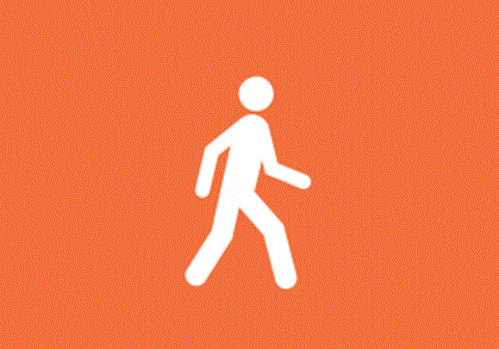 | - cuts and minor burns  - sprains and strains  - broken bones and fracture |  |  |  | Minor Injuries Unit
 | - non emergency medical care and preventive medical care  - illnesses and injuries that cannot be treated by pharmacy, or do not get better  - chronic disease management (eg diabetes, COPD, asthma, heart disease)  - mental health problems  - contraception and sexual health  - vaccinations |  |  |  |  |  |  |  |  |  |  |  |  |  | GP Practice Team  (GP or Nurse)
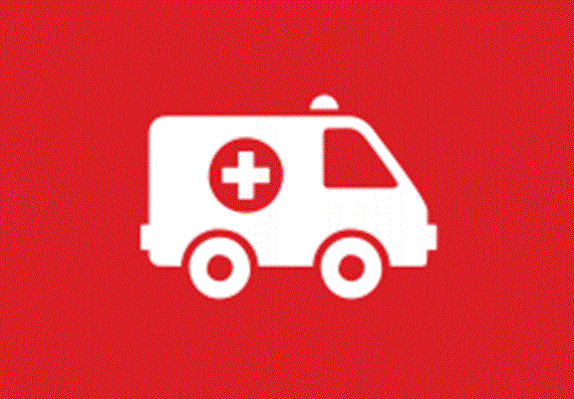 | - significant accidents and medical emergencies  - suspected heart attack or stroke  - breathing difficulties  - severe bleeding |  |  |  |  |  |  |  |  | 999 or A&E
Know Who To Turn To
For services near you visit : www.nhsggc.org.uk/patients-and-visitors/know-who-to-turn-to

